“Together We Learn”
Taylor Elementary School Framework
For Enhanced Student Learning
2020-2021
“Positive Attitudes Will Succeed”

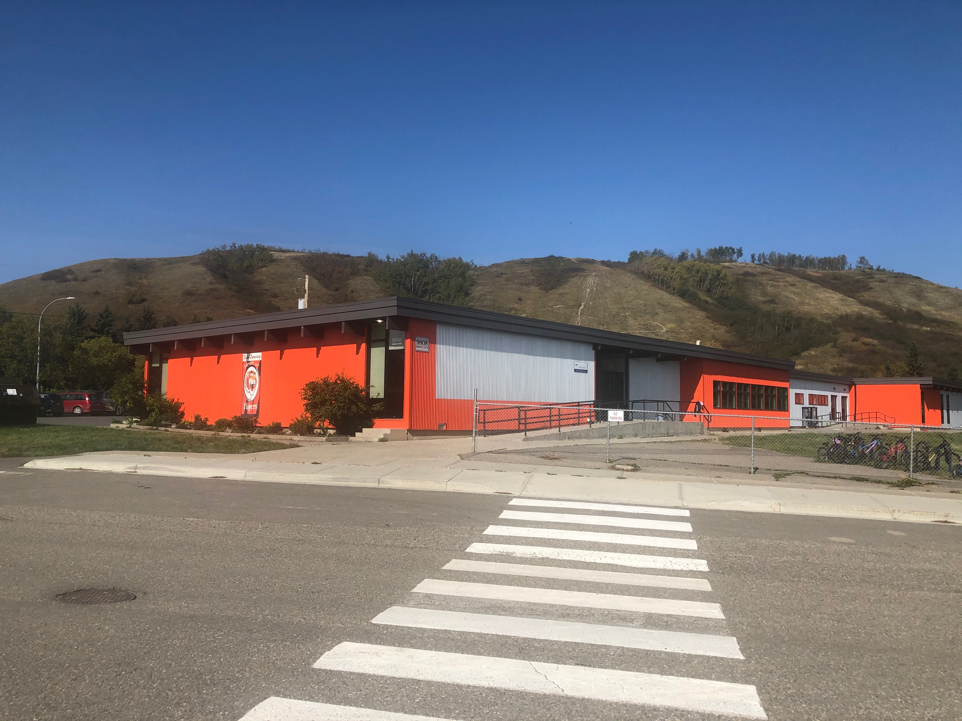
Mission:

The mission of our school community is to educate, inspire and empower all students. We do this by providing challenging and enjoyable learning experiences. Together, as educators and parents, we believe that all students will attain their goals and discover the joy of becoming lifelong learners.

Values:
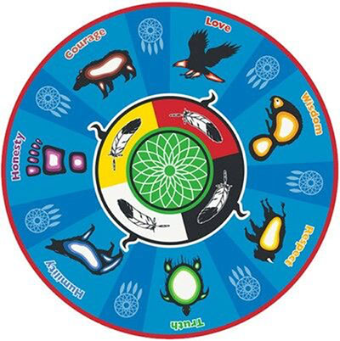
We focus on the seven values from the Seven Teachings common in Indigenous Cultures.
These are: Love, Respect, Honesty, Courage, Wisdom, Humility and Truth

School Context:

Taylor Elementary School is a community-oriented school in the District of Taylor, fourteen kilometers south of Fort St. John. There are one hundred and fifty-two students attending our school. The student body is made up of 23% First Nation heritage. We have twelve teaching staff, and three support staff working with our students. Within the school, pre-school classes and a Strong Start Program operate, which have become an early learning part of our community and created strong bonds with students before they enter kindergarten here.

We continue to work hard to provide great learning opportunities for our students. We embrace BC’s new curriculum and seek to engage students in their learning everyday, focusing on big ideas and experiential learning. We integrate First Nation’s learning into the school, utilizing our Aboriginal Student Support Worker and other resources. We also have a leadership team, which organizes school events throughout the year. Our staff works hard to develop community spirit, as is outlined in our school song (Taylor Tigers/ Eye of the Tiger). We have set up a school-wide house system that promotes school spirit and teamwork. We have an extramural program that involves our intermediate students in a variety of inter-school sports, including cross country, soccer, volleyball, basketball, badminton and track & field.

New this year!
We have implemented morning Zoom meetings every day. These are to bring the school community together daily, announce birthdays and various student achievements (nice drawing, magic trick, an award they received, a presentation they have put together or to feature other skills)

We have a positive school-wide behavior support system (PBIS), and actively support positive behavior through virtual assemblies. We also emphasize Social Responsibility through lesson plans and our WITS program, which addresses any challenges that students face throughout the day, as they learn to Walk away, Ignore, Tell others to stop, and find a Supervisor to assist in finding a positive solution to their challenges.

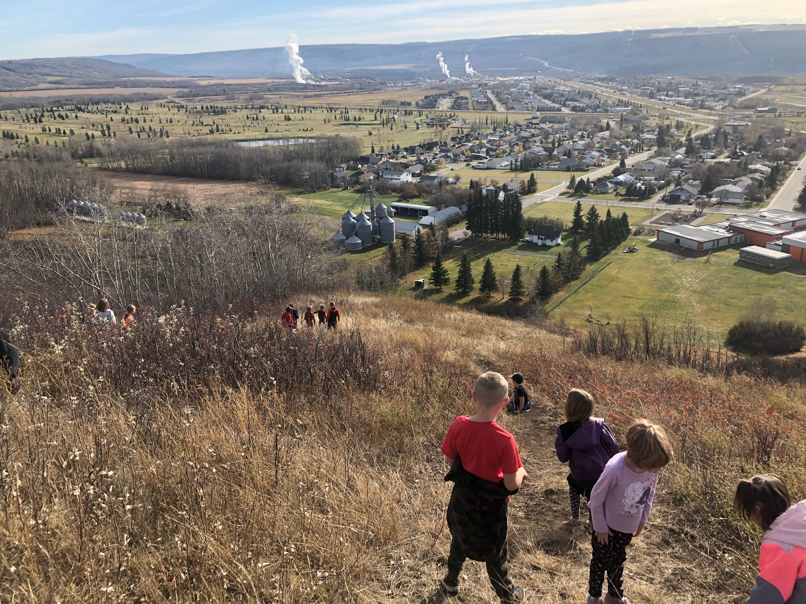

Taylor’s unique setting provides outdoor activities that are not found in many schools. Our students have access to a hill that is utilized during recess and lunch. The hill is used for tobogganing and hiking throughout the year. The District of Taylor is a strong community partner and allows our students access to the skating rink, swimming pool, river, campground/park, golf course, community hall and curling rink. With these partnerships students are able to expand their learning beyond the classroom walls and regular classroom setting.

The parents of Taylor Elementary are actively, every day involved in the development and implementation of school initiatives and goals. The Parent Advisory Council (PAC) continues its tremendous support, through fundraising, special events, Extramurals and special projects. Our PAC and parent volunteers provide tremendous support for our school and all of our students.

1. Improving Student's Reading Comprehension
Goal | Evidence | Target | Strategies
To increase students’ reading comprehension skills and their ability to communicate their understanding while maintaining their fluency. | Language Arts  report card scores  Kindergarten  Phonological  Assessment  PM Benchmarks  QCA, RAD  Assessments  FSA | To have Kindergarten student's achieve quartile 4 by June each year  To have students consistently achieve proficient scores or higher 75% of the time | Adrienne Gear's Powerful Understanding, Reading aloud, Words Their Way, Reading 44, collaborative grouping by ability, leveled home reading, Guided Reading groups, Smart Reading Strategies, library challenges- including Read-A Thon, expanding literacy resources to keep fresh material to engage readers. Use more engaging, individual texts  Focus on current events. Adam Fox, "Thinking Classrooms"
2. Building community in the school
To improve students’ sense of belonging and school pride | Sense of Belonging Survey - School Based | To have 100% feel safe and that they belong | Seven Indigenous Teachings/ Principles  Taylor Tiger Song  Zoom Assemblies daily  Extra Murals/ Sports, Sewing  Cultural Board/ Hallway Focus  Fun Days/ Indigenous Day
3. Improving Number Sense and Math Skills
To improve students’ performance in the knowledge, skills and attitudes related to Mathematics and problem solving. | Math grades on report cards  MAP Assessments  FSA scores | To have students consistently achieve proficient scores or higher 75% of the time | Mathletics Grade 1-6.  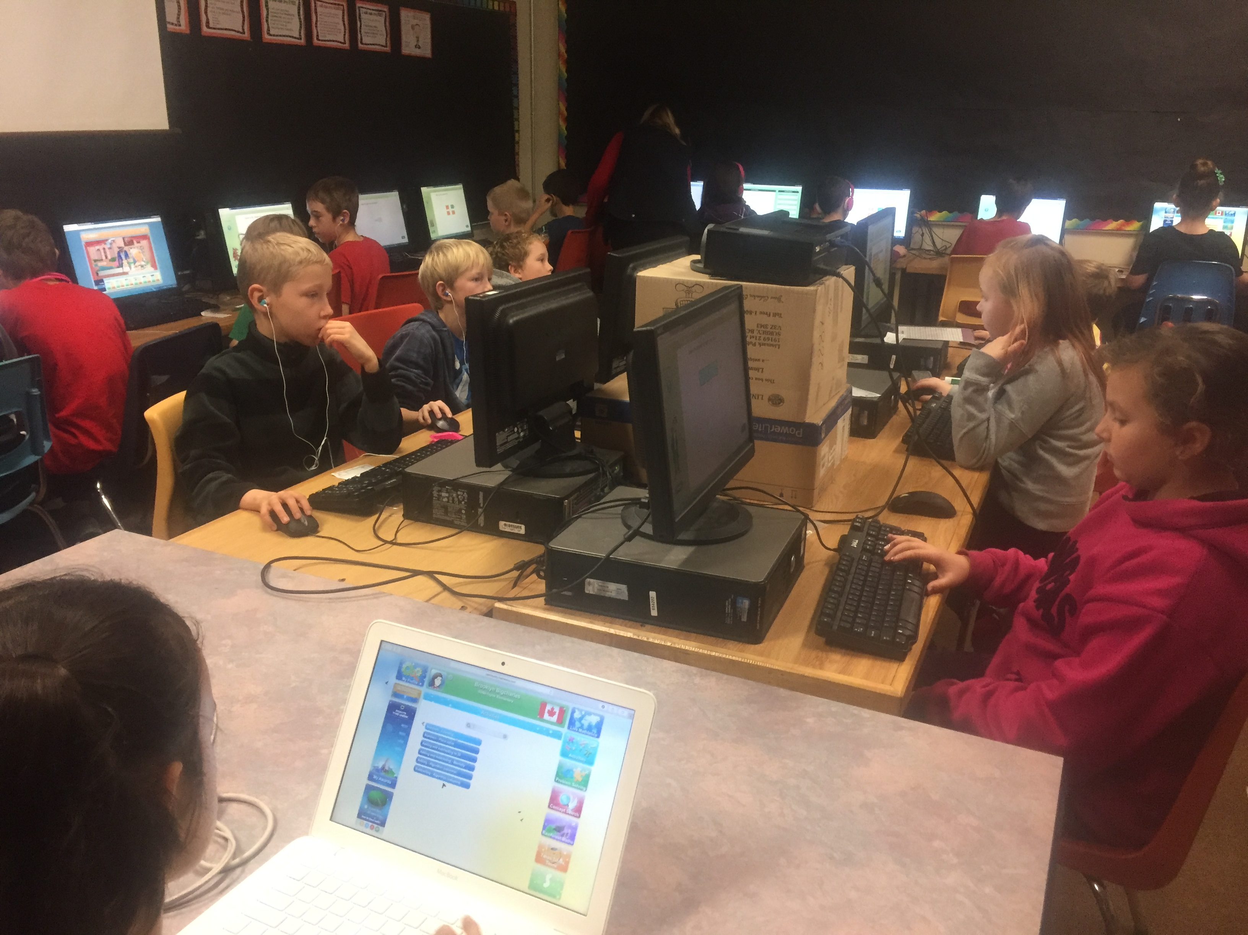  Use of manipulatives and real world application  Activities to focus on number sense, including MAP strategy

